KINGSLEY COMMUNITY PRIMARY & NURSERY SCHOOL

Anti-Bullying Policy

Presented to Staff: September 2022
To be Approved by Governors: Summer 2022
Revised: Summer 22
To be reviewed: Summer 23

Overview:

Kingsley Community Primary School and Nursery is a place where everyone has the right to be themselves. It’s a place where everyone can feel safe, be happy and learn. Everyone at our school is equal and acts with respect and kindness towards each other. Our school is a bully-free place.

Aims and purpose of the policy:

Bullying of any kind is unacceptable and will not be tolerated at our school. At our school the safety, welfare and well-being of all pupils and staff is a key priority. We take all incidences of bullying seriously and it is our duty as a whole school community to take measures to prevent and tackle any bullying, harassment or discrimination.
We actively promote values of respect and equality and work to ensure that difference and diversity is celebrated across the whole school community. We want to enable our pupils to become responsible citizens and to prepare them for life in 21st Century Britain. These values reflect those that will be expected of our pupils by society, when they enter secondary school and beyond in the world of work or further study.
We are committed to improving our school’s approach to tackling bullying and regularly monitor, review and assess the impact of our preventative measures.

1. Definition of bullying

Bullying is hurtful or unkind behaviour which is deliberate and repeated. Bullying can be carried out by an individual or a group of people towards an individual or group. The STOP acronym can be applied to define bullying – Several Times On Purpose.

The nature of bullying can be:

- Physical – such as hitting or physically intimidating someone, or using inappropriate or unwanted physical contact towards someone.
- Attacking property – such as damaging, stealing or hiding someone’s possessions.
- Verbal – such as name calling, spreading rumours about someone, using derogatory or offensive language or threatening someone.
- Psychological – such as deliberately excluding or ignoring people.
- Cyber – such as using text, email or other social media to write or say hurtful things about someone.

Bullying can be based on any of the following things:

- Race (racist bullying)
- Religion or belief
- Culture or class
- Gender (sexist bullying)
- Sexual orientation (homophobic or biphobic bullying)
- Gender identity (transphobic bullying)
- Special Educational Needs (SEN) or disability
- Appearance or health conditions
- Related to home or other personal situation
- Related to another vulnerable group of people

NO form of bullying will be tolerated and all incidents will be taken seriously.

2. Reporting bullying

PUPILS WHO ARE BEING BULLIED: If a pupil is being bullied they are encouraged to not retaliate but to tell someone they trust about it such as a friend, family member or trusted adult. They are also encouraged to report any bullying incidents in school:

- Report to a teacher e.g. Lucy Hargreaves (our anti-bullying lead) their class teacher, or any other teacher.
- Tell our wellbeing ambassadors (look for the golden tie!) who in turn can help them tell a teacher or staff.
- Tell any other adult staff in school – such as lunchtime supervisors, Teaching Assistants or the school office.
- Tell an adult at home.
- Report anonymously.
- Call ChildLine to speak with someone in confidence on 0800 1111

Reporting – roles and responsibilities:

STAFF: All school staff, both teaching and non-teaching (for example midday supervisors and caretakers) have a duty to report bullying, to be vigilant to the signs of bullying and to play an active role in the school’s measures to prevent bullying. If staff are aware of bullying, they should reassure the pupils involved and inform their class teacher.
The following staff member is the anti-bullying lead: Lucy Hargreaves

SENIOR STAFF: The Senior Leadership Team and the head teacher have overall responsibility for ensuring that the anti-bullying policy is followed by all members of staff and that the school upholds its duty to promote the safety and well-being of all young people. In addition to the designated anti-bullying lead, Lucy Hargreaves, is the Senior Leader responsible for anti-bullying.

PARENTS AND CARERS: Parents and carers should look out for potential signs of bullying such as distress, lack of concentration, feigning illness or other unusual behaviour. Parents and carers should encourage their child not to retaliate and support and encourage them to report the bullying. Parents and carers can report an incident of bullying to the school either in person, or by phoning or emailing the school office or a member of staff. If required, Lucy Hargreaves’ email is lhargreaves@kingsleycp.cheshire.sch.uk

PUPILS: Pupils should not take part in any kind of bullying and should watch out for signs of bullying among their peers. They should never be bystanders to incidents of bullying, but should offer support to the victim and, if possible, help them to tell a trusted adult.

3. Responding to bullying

When bullying has been reported, the following actions will be taken:

- Staff will record the bullying on an incident reporting form and also record the incident centrally on CPOMS.
- Designated school staff (SLT and designated anti-bullying lead, Lucy Hargreaves) will monitor incident reporting forms and information recorded on CPOMS analysing and evaluating the results.
- Staff will offer support to the target of the bullying in discussion with the pupil’s class teacher. Individual meetings will then be held with any target of bullying to devise a plan of action that ensures they are made to feel safe and reassured that the bullying is not their fault. Action plans will make use of buddy systems, wellbeing ambassadors, playground monitoring and anti-bullying questionnaires.
- Staff will pro-actively respond to the bully who may require support. They will discuss with the target’s class teacher to devise a plan of action.
- Staff will decide whether to inform parents or carers and where necessary involve them in any plans of action .
- Staff will assess whether any other authorities (such as police or the local authority) need to be involved, particularly when actions take place outside of school.
- When tackling HBT bullying, staff will follow our Kingsley script as follows:

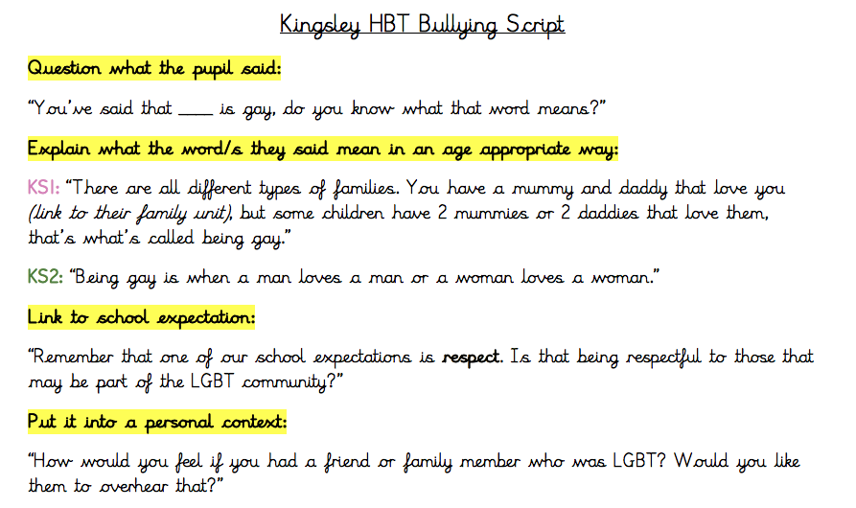

4. Bullying outside of school

Bullying is unacceptable and will not be tolerated, whether it takes place inside or outside of school. Bullying can take place on the way to and from school, before or after school hours, at the weekends or during the holidays, or in the wider community. The nature of cyber bullying in particular means that it can impact on pupils’ well-being beyond the school day. Staff, parents and carers, and pupils must be vigilant to bullying outside of school and report and respond according to their responsibilities as outlined in this policy.

5. Derogatory language

Derogatory or offensive language is not acceptable and will not be tolerated. This type of language can take any of the forms of bullying listed in our definition of bullying. It will be challenged by staff and recorded and monitored on CPOMS and follow up actions and sanctions, if appropriate, will be taken for pupils and staff found using any such language.

6. Prejudice-based incidents

A prejudice-based incident is a one-off incident of unkind or hurtful behaviour that is motivated by a prejudice or negative attitudes, beliefs or views towards a protected characteristic or minority group. It can be targeted towards an individual or group of people and have a significant impact on those targeted. All prejudice-based incidents are taken seriously and recorded and monitored in school, with the head teacher regularly reporting incidents to the governing body. This not only ensures that all incidents are dealt with accordingly, but also helps to prevent bullying as it enables targeted anti-bullying interventions.

7. School initiatives to prevent and tackle bullying

We use a range of measures to prevent and tackle bullying including:

- Our ‘Health and Relationships and Wider PSHE’ curriculum includes opportunities for pupils to understand about different types of bullying and what they can do to respond and prevent bullying.
- Daily school assemblies, including a weekly ‘No Outsiders’ assembly, help raise pupils’ awareness of bullying and derogatory language.
- Difference and diversity are celebrated across the school through diverse displays, books and images. We also follow ‘No Outsiders’ so a different protected characteristic is covered across every year group in each half-term. Additionally, the whole school participates in events including Anti-Bullying Week and Black History Month.
- The school values of equality and respect are embedded across the curriculum to ensure that it is as inclusive as possible.
- Stereotypes are challenged by staff and pupils across the school.
- Wellbeing ambassadors offer support to all pupils, including those who may have been the target of bullying.
- Restorative justice sessions provide support to targets of bullying and those who show bullying behaviour.
- Pupils are continually involved in developing school-wide anti-bullying initiatives through consultation with school council and through anti-bullying questionnaires.
- Working with parents and carers and in partnership with community organisations to tackle bullying, where appropriate.
- A child-friendly anti-bullying policy has been created by the school council. It is displayed in toilets, on well-being displays and in all classrooms, ensuring all pupils understand and uphold the anti-bullying policy. This policy is as follows:

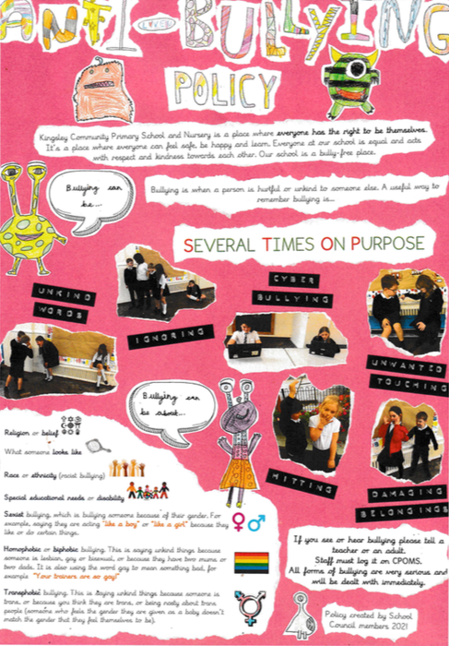

8. Training

The head teacher is responsible for ensuring that all school staff, both teaching and non- teaching (including midday supervisors and caretakers) receive regular training on all aspects of the anti-bullying policy.

9. Monitoring and reviewing

The head teacher is responsible for reporting to the governing body (and the local authority where applicable) on how the policy is being enforced and upheld, via the termly report. The governors are in turn responsible for monitoring the effectiveness of the policy via the termly report and by in-school monitoring such as learning walks and focus groups with pupils.
The policy is reviewed every 12 months, in consultation with the whole school community including staff, pupils, parents, carers and governors.

