

Kingsley CP Curriculum Overview

Year 5 Autumn Term 1

Science:

In Science, we will be learning about…

Animals including human

Key vocabulary:

* Growth
* Aging
* Changes,
* Human,
* Description.
* Physical
* Development
* Gestation
* Puberty

Key knowledge:

* To describe changes as humans develop to old age;
* To explain how a human foetus develops.
* To compare the gestation periods of different mammals.
* To recognise the physical developments of a child
* To describe the changes involved with puberty.
* To explain some of the difficulties associated with old age and how they can be treated.

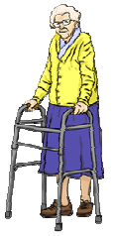

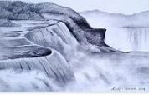Art

In Art we will be learning about…

Line and other sketching techniques to sketch waterfalls using graphite

Key vocabulary:

* tone
* pattern
* texture
* line
* hatching
* scribbling
* stippling
* blending
* light
* dark

Key knowledge:

* To work in a sustained and independent way to create a detailed drawing.
* To develop a key element of their work: line, tone, pattern, texture.
* To use different techniques for different purposes i.e. shading created via hatching within their own work.
* To develop further simple perspective in using a single focal point and horizon.

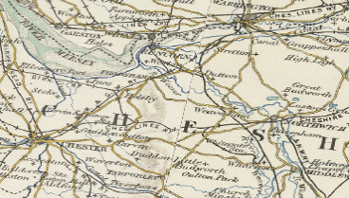Geography

In Geography, we will learning about our local environment.

Key vocabulary

* Sandstone
* Delamere
* Trails
* Market
* Farming
* Urban
* Rural

Key knowledge:

• describe where the UK is located, and that it consists of England, Scotland, Wales and

Northern Ireland

• name and locate some key topographical features of the UK

• locate where they live within the UK

• describe changes that have happened in their local area

• share their hopes for the future of the area

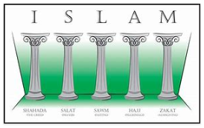Religious Education

In Religious Education, we will be exploring the question:

Why are the Five Pillars important to Muslims?

Key vocabulary:

* Islam
* Shahadah
* Sawm
* Salat
* Zakah
* Hajj
* Pilgrimage

Key knowledge:

* What are the Five Pillars of Islam? What is the Shahadah?
* How do Muslims prepare for Prayer?
* Why do Muslims fast? (Sawm)
* What is the pattern of prayer for Muslims? (Salat)
* How do Muslims show care for others? (Zakah)
* Why do Muslims go on Pilgrimage? (Hajj)

[](https://www.bing.com/images/search?q=cartoon+computer+images&id=2AEBC44206DC3513438F520B027F794515F6D5F7&FORM=IQFRBA)Computing

In Computing, we will be learning about Systems and searching.

Key vocabulary

* Search engines
* Research
* Systems
* Ordering
* Digital

Key knowledge:

* To describe some of the ways that search results can be influenced
* To recognise some of the limitations of search engines
* To explain how search engines make money
* To order a list by rank
* To explain that a search engine follows rules to rank results
* To give examples of criteria used by search engines to rank results

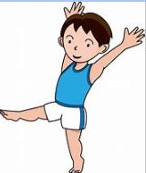Physical Education

In Physical Education, we will be learning about…

Gym and invasion games



Key knowledge:

Gym

* To perform a variety of balances with a partner
* To perform a variety of balances using apparatus
* To create a 3-part sequence with a partner.
* To perform and evaluate a sequence

Invasion games

* To send and control a ball
* To plan a perform evasive techniques
* To develop awareness of tactics
* To develop tactics and apply in a game situation

Key vocabulary

* Long ball
* Dummy
* Patience
* Creating space
* Attack
* Defend
* Pressure
* Awareness

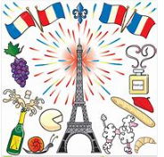MFL

In MFL, we will be learning French words and phrases for…

My school and subjects

Key vocabulary

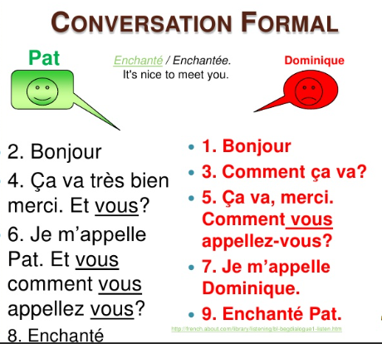

Key knowledge:

* To introduce myself
* To express how I am feeling
* To use French words for school subjects
* To give my opinions about school in French

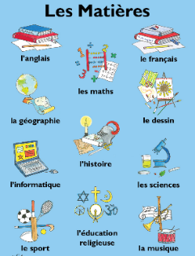

Music

In Music, we will be learning about… Rock Anthems 

Key knowledge:

* I can confidently identify and move to the pulse.
* I can take it in turn to discuss how the song makes them feel.
* I can listen carefully and respectfully to other people’s thoughts about the music.
* To appraise a piece of music
* To reflect on the composer and composition
* To pick up lyrics and sing in tune with a piece of music.

Key vocabulary

Pulse and rhythm

appraising

arrangement

composing

style

texture

PSHE

In PSHE, we will be learning about… Me and my relationships

Key knowledge:

* To express feelings and emotions and learn to manage these
* To understand traits of a good friend
* To know what is meant by friendships
* To understand the importance of compromise in friendships
* To use and understand assertive skills.

Key vocabulary

Friendship

Compromise

Assertiveness

Relationship

Empathy

Self-awareness