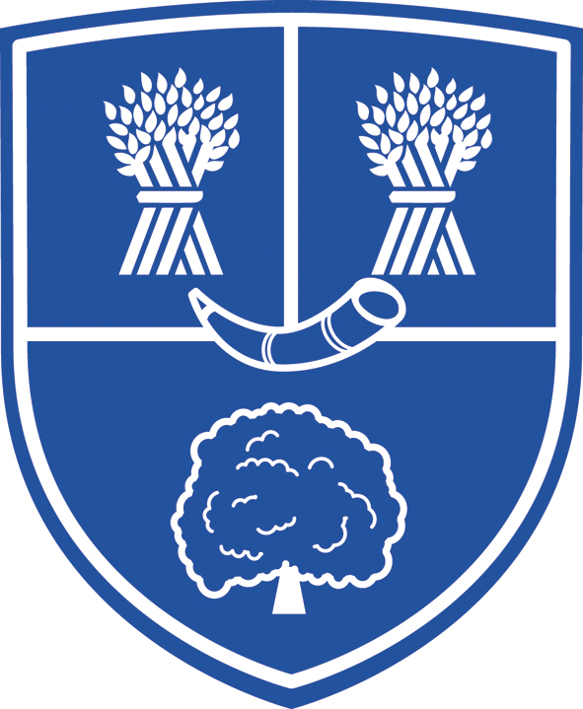
KINGSLEY COMMUNITY PRIMARY & NURSERY SCHOOL
Middle Lane
Kingsley
Frodsham
Cheshire
WA6 6TZ
Tel. 01244 259690
email: admin@kingsleycp.cheshire.sch.uk
Headteacher: Mrs S Harrison B.Ed Hons, NPQH
8th June 2021
Year 5 Go-Ape Trip – Wednesday 16th June 2021

Dear parents,

We are really looking forward to our trip to Go-Ape on Wednesday 16th June 2021. We will be leaving school at 9.15am and will be returning to school for 3pm.

The kit that your child will need to bring on the day (in a small rucksack that they can carry) is…
*a waterproof coat
*a sunhat or cap
*sun cream
*a water bottle (essential)
*their packed lunch (pre-ordered school lunches will be given out in the classroom on the morning of the trip)
*a healthy snack

They will need to wear suitable clothing for a day of fun; a long sleeved top, long trousers and trainers (or similar) will be needed to be worn for the Go Ape course. Please pack a jumper/hoodie as it can get chilly in the forest.

If your child has any medical conditions or will need to take medication during the trip, please contact myself or the school office so the necessary forms can be completed prior to the visit. Please can you ensure that all inhalers needed are in date, and in school for the day of the trip.

Please fill in the below information and return it as soon as possible to your child’s class teacher so we can ensure that the trip runs as smoothly as possible.

If you have any further questions about this, please don’t hesitate to contact me.

Kind regards,

Mrs Reeves and Miss Tasker

Year 5 teachers

Go-Ape Trip – Wednesday 16th June 2021

My child…………………………………………………………………………………………………………………….is taking part in the above trip.

I would like to order them a school lunch ham cheese tuna (please circle)

I am making them a packed lunch

My emergency contact number is……………………………………………………………………………………………………………………

Signed………………………………………………………………………………………………………….

Parent Name……………………………………………………………………………………………..

Date……………………………………………………………………………………………………………..

